SIMATS ENGINEERING
ASSESSMENT TOOL 1

NAME: Y Guru Charan
REG NO:192565020
COURSE NAME: COMPUTER NETWORKS
COURSE CODE: CSA0713

Annexure A
Coding challenge
- Write a Python script that generates a star topology diagram (ASCII or graphical) given n host and a central switch. The script must print each host label, the switch name, and the connecting Cat6 UTP cable length.
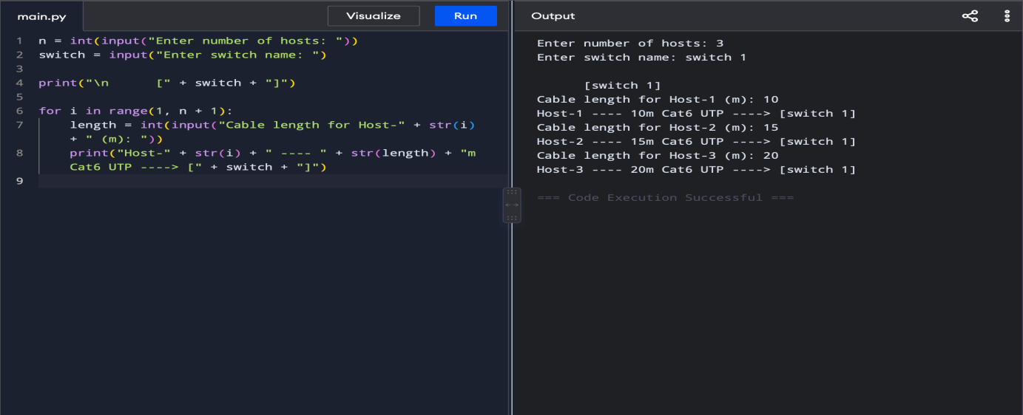
- Code a function `validate_segment(length_m)` that returns True if the UTP segment is within IEEE 802.3 limits (≤100 m) and False with an error message otherwise. Include at least 3 test cases.
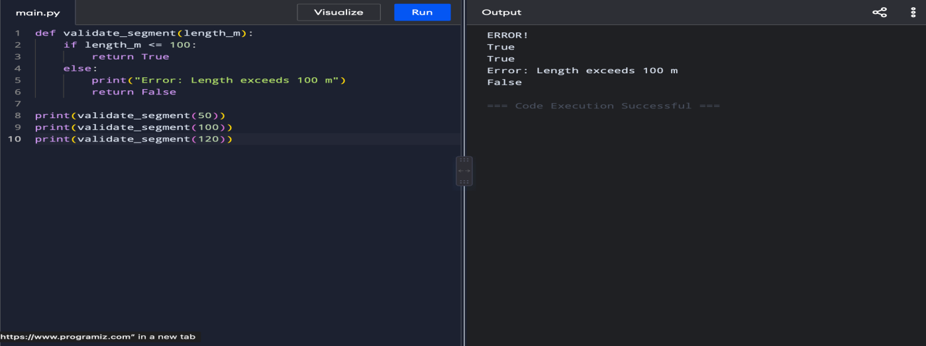

- Write a script that simulates CSMA/CD on a star topology with 4 hosts. Log every collision detection event and the back-off interval to a file named `csma_log.txt`.
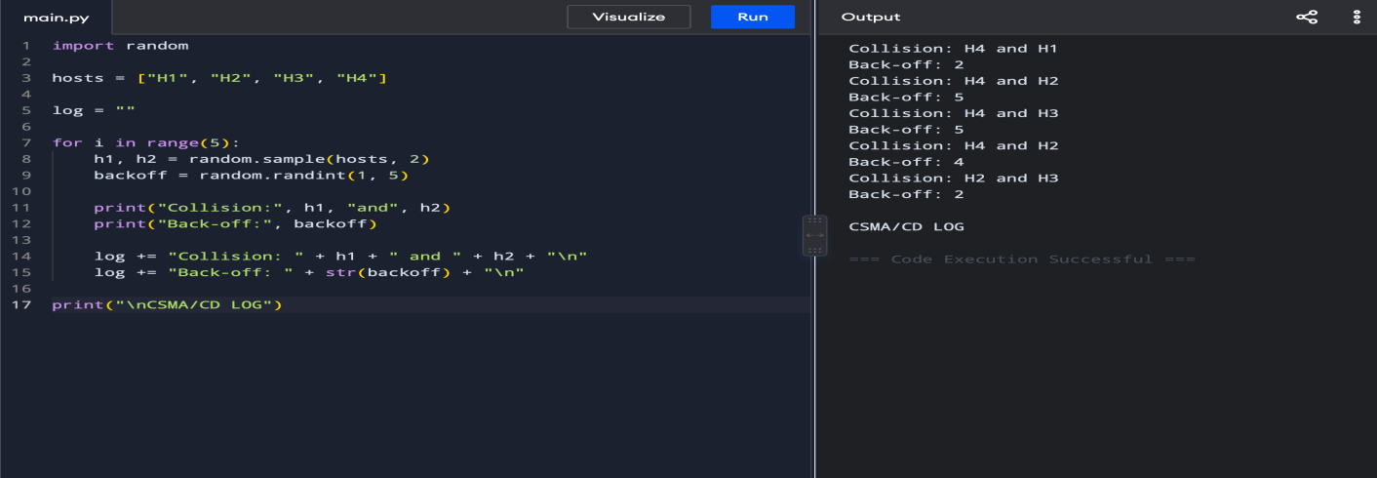
- Using Python's `socket` library, write a client-server program that models two hosts communicating through a star switch. Demonstrate message forwarding by printing the switch's MAC address table after each frame transmission.
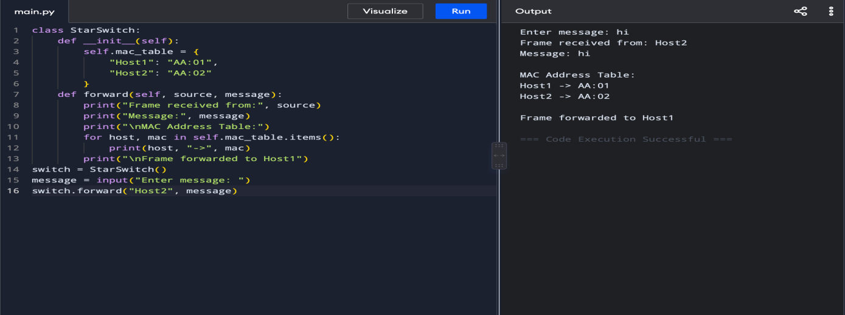
- Create a class `StarSwitch` with methods `add_port(host_id)`, `remove_port(host_id)`, and `broadcast(frame)`. Broadcast must send a frame to all ports except the source and log each delivery.
